**Battle of Verdun**

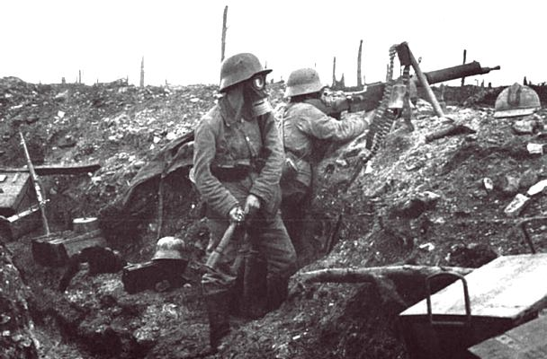

Germany developed a battle plan for attacking Verdun, France, a city protected by a ring of underground forts. Begun in mid-February 1916, and ending in December, the battle of Verdun symbolized for the French the strength and fortitude of their armed forces and the solidarity of the entire nation. After a few short weeks, the battle took on a life of its own, with small groups of men on both sides fighting local battles in constant struggle for their lives, and protection of the territory they occupied. Verdun is still considered by many military historians as the 'greatest' and most demanding battle in history.

The battle came to symbolize the brutality of the entire war. Rather than try to capture land or win an objective, the battle became about killing as many men as possible. In the end, the front lines were nearly the same as when the battles started while over 300,000 French and Germans were killed and over 750,000 were wounded.

**Battle of the Somme:**

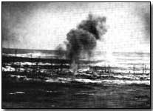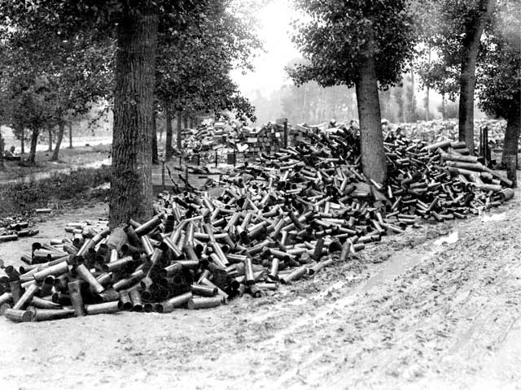

|  |
| --- |
| http://www.pbs.org/greatwar/images/trans.gif |

One hundred and twenty-five miles northwest of Verdun, the British and French armies joined at the Somme River. A Franco-British offensive was planned here for 1916 to relieve pressure on the French at Verdun. British General Douglas Haig ordered a massive bombardment of the German lines that would last a week and could be heard across the Channel in England. But the German troops were deeply dug in and the bombardment did not reach them. Once the shelling was over, of the 100,000 British troops who attacked the German lines July 1, 1916, 20,000 were killed and over 40,000 were wounded. It was the single worst day in deaths and casualties in British military history. Eventually this battle, which did not change the front line trenches much at all, involved over 2 million men along a 30 mile front. British and French losses numbered nearly three-quarters of a million men.

**The Battle of Ypres:**

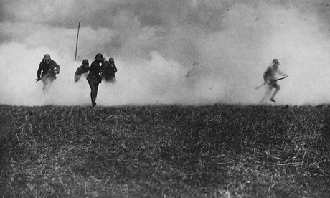

There were three Battles of Ypres during WWI. The city was a strategic northern gate to the sea. Germany deployed poison gasses at this battle for the first time. For years the town and the surrounding areas would be fighting in a brutal blood bath for control over the land. Adolf Hitler fought in the First Battle of Ypres and earned Germany’s highest honors.

British General Douglas Haig often believed his army was on the verge of a breakthrough. His optimism resulted in a plan in 1917 to attack the German lines just outside of Ypres, Belgium. This would be the third battle at Ypres, the other two having taken place in 1914, and 1915. Once Haig's army broke through, he envisioned it sweeping across the low plains and swinging north to the sea.  
   
 On the morning of June 7, 1917, the Allies set off a series of nineteen giant mines dug over eighteen months under the German lines south-east of Ypres. Together with a sophisticated counter-battery operation, this stroke completely disrupted and disorganized German defensive positions. The initial advance ended successfully, but then weeks passed before the British troops were ordered to continue by which time the wettest fall in years had set in. In this three-month battle, men, animals and equipment were swallowed up in mud that was often like quicksand, Haig's ambitious plan became yet another failure. Total Allied and German casualties exceeded 850,000, including the deaths of 325,000 British soldiers.

**Gallipoli:**

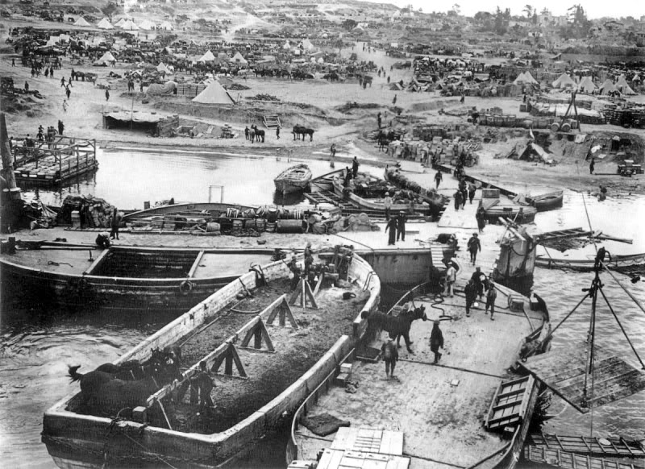

On April 24th, 1915, an amphibious force of British, French, Australian, and New Zealand troops began landing on the Turkish peninsula of Gallipoli. Their aim, to knock Germany's ally, Turkey, out of the war. If they were successful the Allies could send supplies directly to Russia. Only a small Turkish force awaited them on the cliffs overlooking the shore. However, the Gallipoli landing was a disaster caused by inadequate intelligence, insufficient attention to the terrain, an underestimation of the enemy's strength and resilience in defense of their native soil. Nine months after landing, the allies withdrew after incurring over 250,000 casualties, including over 46,000 dead.

The failure would mean that Russia was cut off from their Allies and their supplies. This led to Russia’s lack of weapon power and supplies which would cause mass casualties to the Russian forces. Eventually this would lead to Russia withdrawing from the war.

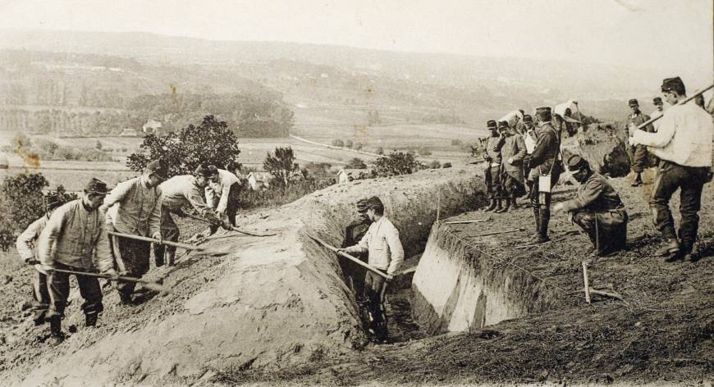**First Battle of the Marne:**

The First Battle of the Marne was conducted between September 6th-12th of 1914.  The battle brought the end of Germany’s advance in the Schlieffen Plan. Instead, with the German advance brought to a halt, stalemate and trench warfare ensued.

Having invaded Belgium and north-eastern France, the German army had reached within 30 miles of Paris.  Their progress had been rapid, having successfully beaten back Belgian, French and British forces in advancing deep into north-eastern France.  Their advance was part of the [Schlieffen Plan](http://www.firstworldwar.com/features/plans.htm), whose primary focus was the swift defeat of France in the west before turning attention the Russian forces in the east.

In a strategic triumph at the First Battle of the Marne, which ended on 10 September, the French forces - assisted by the British - had succeeded in throwing back the German offensive, recapturing lost ground in the process.  More importantly, the battle ended any hopes the Germans had of effectively bringing the war on the Western Front to an early close.

Casualties at the battle were heavy.  The French incurred 250,000 losses, and it is believed that the Germans suffered similar casualties (no official figures are available).  The British recorded 12,733 casualties among the BEF.

**The Second Battle of the Marne:**

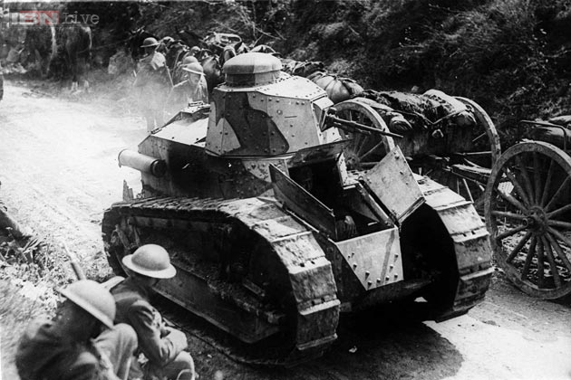

In what began as the last major German offensive of the First World War, the Second Battle of the Marne developed into a significant Allied victory.  After it became clear that the Germans had not only failed in their aim to win the war in this offensive, but had in fact lost ground, a number of German commander believed the war was lost.

With the aid of American forces, the Allies successfully forced Germany to retreat and ended Germany’s final offensive. On 20 July the Germans ordered a retreat; by 3 August they were back where they had started at the launch of the great spring 1918 offensive: at the Aisne-Vesle rivers.  The Allied counter-offensive was finally halted on 6 August by the now solidly entrenched Germans. No further major offensives would be fought during the war.

Casualties were high, more so among the German forces that the Allies.  France suffered 95,000 casualties, Germany 168,000, with Britain incurring 13,000 losses and the U.S. 12,000.

|  |  |  |  |  |
| --- | --- | --- | --- | --- |
| Battle | What Happened? | Why is this important? | How many casualties? | What do you see in the photograph? |
| **Battle of Verdun** |  |  |  |  |
| **Battle of the Somme** |  |  |  |  |
| **Battle of Ypres** |  |  |  |  |
| **Gallipoli** |  |  |  |  |
| **First Battle of the Marne** |  |  |  |  |
| **Second Battle of the Marne** |  |  |  |  |